Modeling and simulation methods in nanotechnology.

Practical laboratory

Solving practical tasks in computer laboratory. 6 hours

Application of gradient descent method for calculation of strain in one-dimensional chain of atoms

Task 1.

Gradient descent method application for a simple analytical function.
Write a computer program implementing gradient descent method for finding minimum of a two-dimensional function: $f(\text{x,y})=x^{2}−6\text{x+}9+2y^{2}−8\text{y+}8$, for which the gradient is given by a simple analytical formula.

Task 2.

Gradient descent method applied to N-dimensional function.
Write a computer program implementing gradient descent method for any N-dimensional (N<=10) user defined function. Consider two cases:
A. gradient given by an analytical formula
B. gradient calculated using numerical approximation:
$$\begin{aligned}f=f(x_{1}{\text{,x}}_{2},\text{.}\text{.}\text{.},x_{n})∇f=\left[\frac{∂f}{∂x_{1}},\text{.}\text{.}\text{.}\frac{∂f}{∂x_{n}}\right] \\ \frac{∂f(x_{1}{\text{,x}}_{2},\text{.}\text{.}\text{.},x_{n})}{∂x_{k}}=\underset{h→0}{\text{lim}}\frac{f(x_{1}{\text{,x}}_{2},\text{.}\text{.}\text{.},x_{k}+h,\text{.}\text{.}\text{.},x_{n})−f(x_{1}{\text{,x}}_{2},\text{.}\text{.}\text{.},x_{k},\text{.}\text{.}\text{.},x_{n})}{h}≈ \\ \frac{f(x_{1}{\text{,x}}_{2},\text{.}\text{.}\text{.},x_{k}+Δx,\text{.}\text{.}\text{.},x_{n})−f(x_{1}{\text{,x}}_{2},\text{.}\text{.}\text{.},x_{k}−Δx,\text{.}\text{.}\text{.},x_{n})}{2Δx}\end{aligned}$$

Final classification task.

Construction and execution of a computer code for minimizing strain energy in one-dimensional chain of atoms.
Apple a gradient descent method and write a computer program finding elastic energy minimum for a one-dimensional chain of N atoms:
$E=\sum_{i=0}^{N−1}{}\begin{aligned}\sum_{j≥0,j≤N−1}{}j=i−1,i+1\end{aligned}$,
where x_{i} are atomic positions. d_{ij} is a bond length between i and j atoms, A_{ij} are force constants related to bond squeezing or stretching.
The picture below show the example input data for a chain, where atoms are coded by color (Red, Green, Blue). The equilibrium bond lengths and force constants are also given in the input. Just like in case of real semiconductor compounds (e.g. InAs) the bonds are only allowed between atoms of specific colors (kinds), i.e. B-G and B-R.
Important notice: the edge atoms positions are not modified (are frozen) during the optimization process!!!
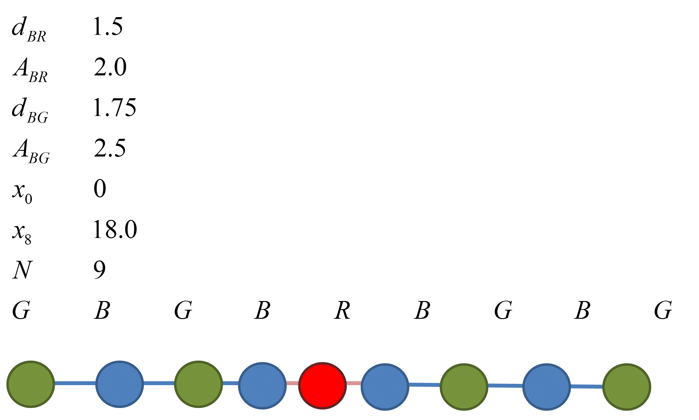
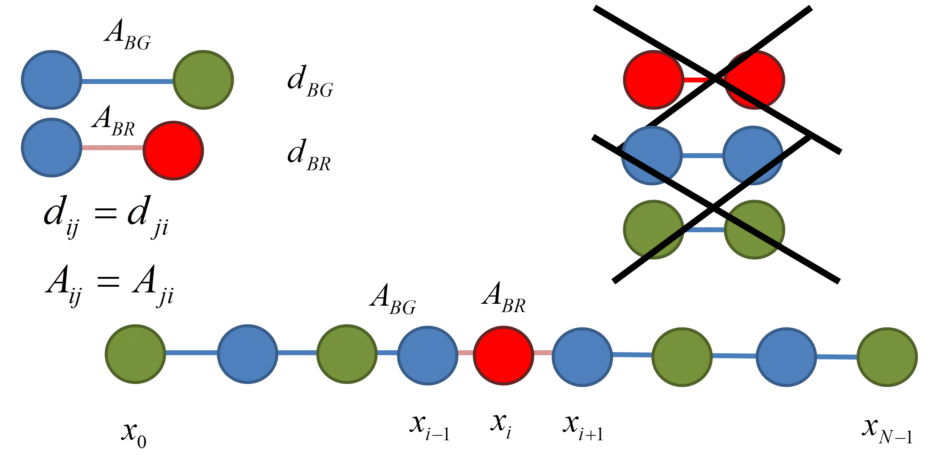
Program output should include optimized atomic position and strain values for each chain atom:
$\begin{aligned}ε\left(x_{i}\right)=\frac{\left(x_{i+1}−x_{i}\right)−d_{i,i+1}+(x_{i}−x_{i−1})−d_{i,i−1}}{d_{i,i+1}+d_{i,i−1}}=\frac{\left(x_{i+1}−x_{i−1}\right)−\left(d_{i,i+1}+d_{i,i−1}\right)}{d_{i,i+1}+d_{i,i−1}} \\ \text{for} i=1,\text{.}\text{.}\text{.},N−2\end{aligned}$
Program should also return total number of iterations, gradient length and elastic energy value calculated during each iteration.
Students can chose any language or computational package they wish Fortran, C, C++, C#, Matlab, Phyton, etc.).
For classification, students must demonstrate they now their codes in detail. They must execute the code for a system (input data) chosen by the teacher.

