Profile MMSE - pomiar 2
- Dane: statystyki opisowe (6 cech) + charakteryzacja kształtów roskładu profili (4 cechy: średnia, odchylenie, skośność i kurtoza z gęstości)
Wizualizacja profili MMSE

Płeć

Klasyfikacja 2 klasowa
- KLasy: przeskalowane wyniki testu < 11.3
- Testy: GM + std + 10x5CV - wszystko poniżej baserate

Wizualizacja QPC
>> w2=qpctrain(xn,double(c2),'plot','qpc','display','short');
procedure = qpc
dataname = data
vectors = 43
features = 10
OptMethod = gd
learningRate = 0.100000
prototypes = 0
proto lr = 0.000000
eps = 0.001000
start init. = 10
end init = 3
multistart = yes
maxIterations = 1000
qpc function = @(wx,p)qpcfunction(x,ci,wx,[],func)
function = @(x)f_gauss(x,parameters.beta)
beta = 0.100000
Performing 10 initiations - Gradient based optimization (MultiStart)
Sprawdzic dokladniej czy dobrze
5 initiations was killed
Finish N = 120 QPC = 0.208580 [1 ]
-0.4560 -0.1730 -0.3320 -0.4411 -0.3017 -0.2253 -0.2223 -0.2117 0.3252 -0.3399
Finish N = 125 QPC = 0.207879 [5 ]
-0.3491 -0.1533 -0.3375 -0.4421 -0.4247 -0.2325 -0.4004 -0.1394 0.2099 -0.2951
Finish N = 165 QPC = 0.207839 [2 ]
-0.2781 -0.0500 -0.3092 -0.4222 -0.3757 -0.3861 -0.3210 -0.1927 0.2781 -0.3722
Finish N = 175 QPC = 0.207835 [6 ]
-0.2780 -0.1134 -0.3430 -0.4539 -0.3963 -0.3691 -0.3521 -0.1420 0.2542 -0.2902
Finish N = 180 QPC = 0.207927 [7 ]
-0.4938 -0.0749 -0.3447 -0.4402 -0.3056 -0.2249 -0.3799 -0.1363 0.2378 -0.2731
Best: 0.208580 -0.4560 -0.1730 -0.3320 -0.4411 -0.3017 -0.2253 -0.2223 -0.2117 0.3252 -0.3399
---------------Sumary--------------------------
Initialization 1 was the best
N QPC W
0 0.2086 -0.4560 -0.1730 -0.3320 -0.4411 -0.3017 -0.2253 -0.2223 -0.2117 0.3252 -0.3399
-----------------------------------------------
procedure = qpc
dataname = data
vectors = 43
features = 10
OptMethod = gd
learningRate = 0.100000
prototypes = 0
proto lr = 0.000000
eps = 0.001000
start init. = 10
end init = 3
multistart = yes
maxIterations = 1000
qpc function = @(wx,p)qpcfunction(x,ci,wx,[],func)
function = @(x)f_gauss(x,parameters.beta)
beta = 0.100000
Performing 10 initiations - Gradient based optimization (MultiStart)
Sprawdzic dokladniej czy dobrze
7 initiations was killed
Finish N = 205 QPC = 0.128676 [2 ]
-0.2283 -0.0745 0.1508 0.0456 -0.2454 -0.5509 -0.3700 0.3563 0.1016 0.5288
Finish N = 235 QPC = 0.128780 [7 ]
0.1028 0.0219 -0.2325 -0.1533 0.1983 0.4898 0.2170 -0.4285 -0.1401 -0.6179
Finish N = 520 QPC = 0.065417 [5 ]
-0.2907 0.1032 0.2324 -0.4789 -0.3177 -0.1452 0.4339 -0.1645 -0.4864 0.2183
Best: 0.128780 0.1028 0.0219 -0.2325 -0.1533 0.1983 0.4898 0.2170 -0.4285 -0.1401 -0.6179
---------------Sumary--------------------------
Initialization 7 was the best
N QPC W
0 0.1288 0.1028 0.0219 -0.2325 -0.1533 0.1983 0.4898 0.2170 -0.4285 -0.1401 -0.6179
-----------------------------------------------
scaterplot(xn*w2',double(c2))
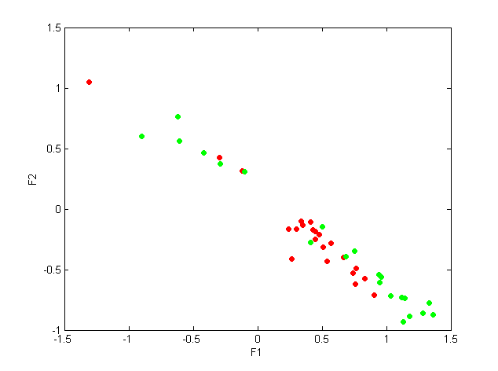
bar(abs(w2(1,:)))


