QPC+NaiveBayes CV test on 10 first projections for Sonar
Test klasyfikacji 10x10CV dla modelu Naive Bayes (przy założeniu rozkładu normalnego, default Matlab settings) uczonego na całym zbiorze Sonar oraz na pierwszych 10 kierunkach znalezionych przez QPC maksymalizowanego za pomocą spadku gradientu oraz za pomocą zmodyfikowanej wersji QPC bazującej na zbiorze prototypów referencyjnych i inicjowanej za pomocą podziału losowych projekcji na interwały.

10x10 CV, 10 first projections (10.05.15)
10x10 CV
normalization
QPC parameters
lr = 0.1
optimization = gradient descent
dataset= sonar
vectors= 208
features= 60
folds= 10
repetitions=10
ttest paired corrected
Naive Bayes (all data)
acc. | std.
67.95 | 11.28
Dim. | QPC |  | T-Test vs. NB | QPC2 |  | T-Test vs. NB | T-Test vs. QPC
 | acc. | std. | p-value | acc. | std. | p-value | p-value
1 | 74.41 | 9.44 | 0.0819 | 74.23 | 8.45 | 0.0700 | 0.9290
2 | 75.19 | 8.68 | 0.0482 | 74.60 | 9.52 | 0.0621 | 0.8029
3 | 76.68 | 9.11 | 0.0195 | 74.56 | 9.08 | 0.0683 | 0.3609
4 | 76.61 | 8.33 | 0.0182 | 76.39 | 9.16 | 0.0213 | 0.9255
5 | 76.87 | 8.05 | 0.0195 | 76.73 | 8.61 | 0.0145 | 0.9479
6 | 77.50 | 7.32 | 0.0114 | 78.31 | 8.41 | 0.0041 | 0.7347
7 | 77.49 | 7.52 | 0.0112 | 78.62 | 7.80 | 0.0025 | 0.6373
8 | 78.69 | 7.17 | 0.0039 | 79.19 | 8.38 | 0.0020 | 0.8445
9 | 78.55 | 7.32 | 0.0039 | 78.86 | 8.78 | 0.0037 | 0.9017
10 | 78.56 | 7.66 | 0.0039 | 79.09 | 9.17 | 0.0022 | 0.8328
Dim. - number of linear ptojections generated by QPC
QPC2 - fast QPC method based on subset of reference prototypes
NB - Naive Bayes with normal distribution assumption
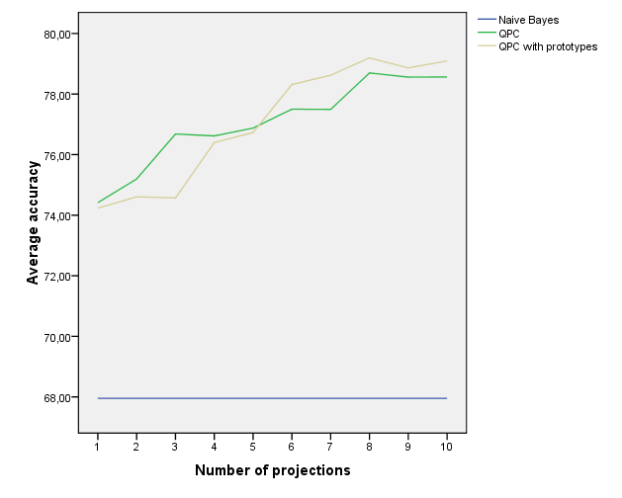{{:projects:models:qpc_and_naivebayes:sonar_10x10_dim_1_10.png|

1x10 CV , 10 first projections (10.05.14)
1x10 CV
normalization
QPC parameters
lr = 0.1
optimization = gradient descent
NaiveBayes
acc. | std.
70.64 | 13.80
Dim. | QPC + NB |  | QPC2 + NB
 | acc. | std. | acc. | std.
1 | 74.02 | 14.25 | 73.02 | 10.55
2 | 74.52 | 13.29 | 74.97 | 10.29
3 | 76.02 | 13.93 | 76.95 | 12.21
4 | 77.90 | 12.51 | 78.85 | 10.32
5 | 77.42 | 12.65 | 79.83 | 10.18
6 | 76.47 | 12.72 | 77.90 | 11.68
7 | 76.95 | 12.79 | 77.45 | 11.81
8 | 76.95 | 11.77 | 78.88 | 10.75
9 | 78.38 | 11.91 | 78.40 | 11.21
10 | 79.33 | 12.30 | 78.90 | 11.40
Dim. - number of linear ptojections generated by QPC
QPC2 - fast QPC method based on subset of reference prototypes
NB - Naive Bayes with normal distribution assumption


