Dane Grid 8x8 - Wizualizacje QPC
vectors = 750
features = 64
classes = 5
- Opis danych
- Wizualizacja MDS
- Wizualizacja QPC (jedna klasa kontra reszta danych)

Rozwiazanie 1
Pierwszy kierunek
G(x)=1/(1+(βx)4)
β=2
learningRate = 0.2
maxIterations = 1000
initiations = 5
eps = 0.001
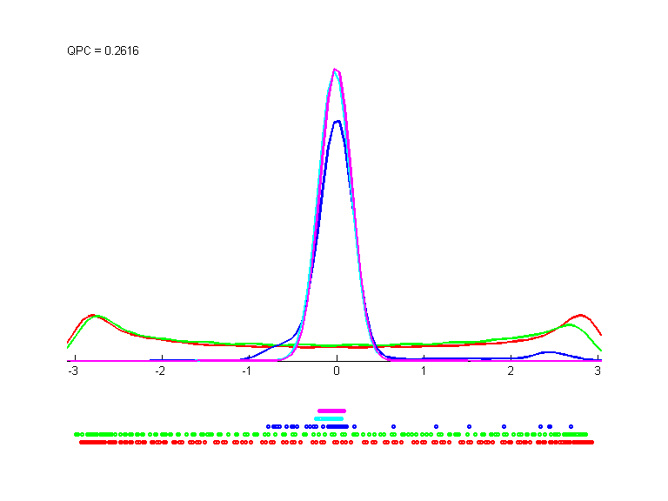
w1 = 0.0568 0.0401 -0.0218 -0.0393 -0.0915 -0.1059 -0.1178 -0.2416 0.1356 0.0755 0.0231 -0.0695 -0.1154 -0.1102 -0.1212 -0.2144 0.1747 0.1123 0.0391 -0.0834 -0.1343 -0.1259 0.1005 0.0825 0.1695 0.1553 0.0458 -0.0884 -0.1155 0.0385 0.2121 0.2806 0.0901 0.0778 0.0084 -0.0935 -0.1483 -0.0552 0.1863 0.3399 0.0137 0.0022 -0.0357 -0.1261 -0.1621 -0.2092 -0.0358 0.0902 0.0278 0.0175 -0.0055 -0.0953 -0.1832 -0.1921 -0.1495 -0.1302 0.1122 0.0676 0.0768 0.0425 -0.0401 -0.1359 -0.1100 -0.0996
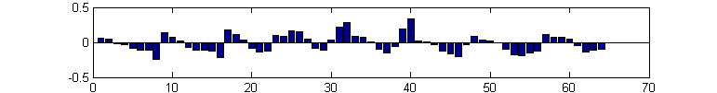
Drugi kierunek
lambda = 1.0
G(x)=1/(1+(βx)4)
β=2
learningRate = 0.2
maxIterations = 1000
initiations = 5
eps = 0.001
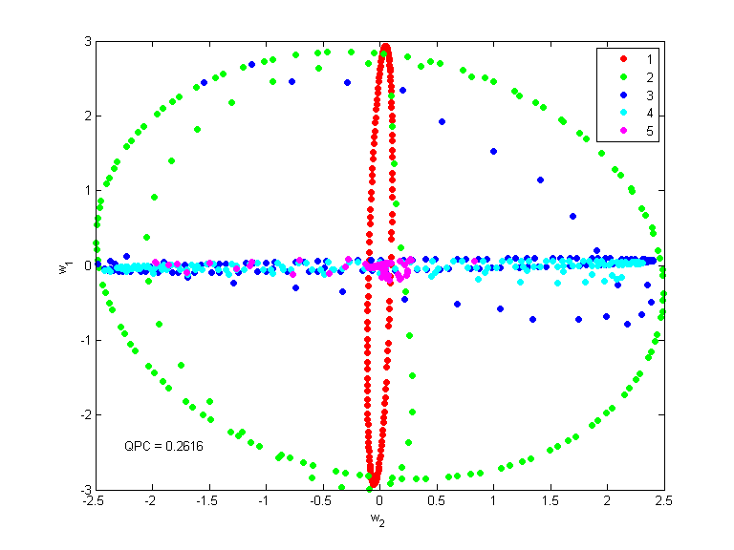
w2 = -0.2618 -0.0652 0.1794 0.1900 -0.1580 -0.2867 -0.1956 -0.1204 -0.2799 -0.1254 0.0463 0.1132 -0.0743 -0.1424 -0.0597 0.0216 -0.3037 -0.2670 -0.0335 -0.1510 -0.1494 -0.2315 0.0704 0.0247 -0.0695 -0.1056 -0.0733 -0.1208 -0.0857 0.0128 0.1014 0.0646 -0.0777 -0.0281 -0.0939 -0.0142 0.1443 0.0887 0.1504 0.1119 0.0063 -0.0471 -0.0463 -0.0423 0.1047 0.0480 -0.0007 -0.0388 0.0450 -0.0618 0.0761 0.0668 0.1376 0.0730 0.0750 0.0067 0.0307 -0.0585 0.0878 0.1906 0.1089 0.1154 0.0638 0.0951
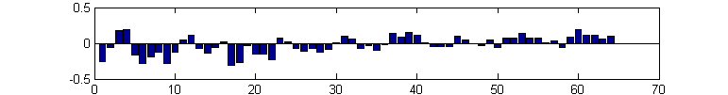
Inne ciekawe rozwiązania uzyskane z tymi samymi parametrami
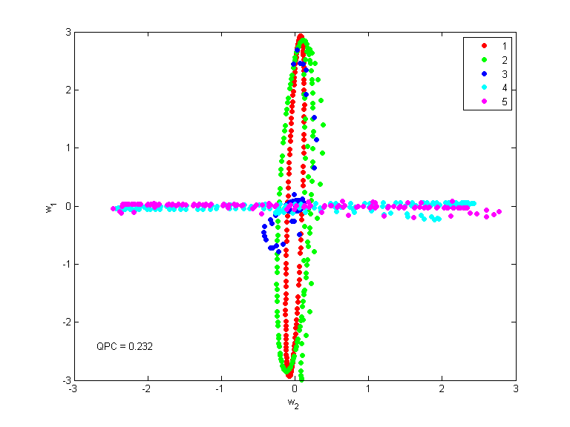
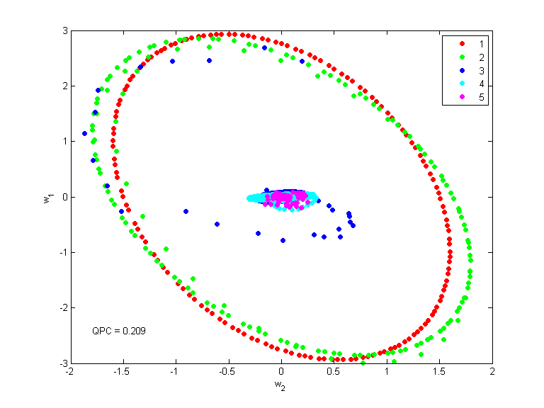

Rozwiazanie 2 (f. bicentralna, β=0.3)
Pierwszy kierunek
G(x)= σ(x+β)(1-σ(x-β))
β=0.3
learningRate = 0.1
maxIterations = 1000
initiations = 10
eps = 0.001
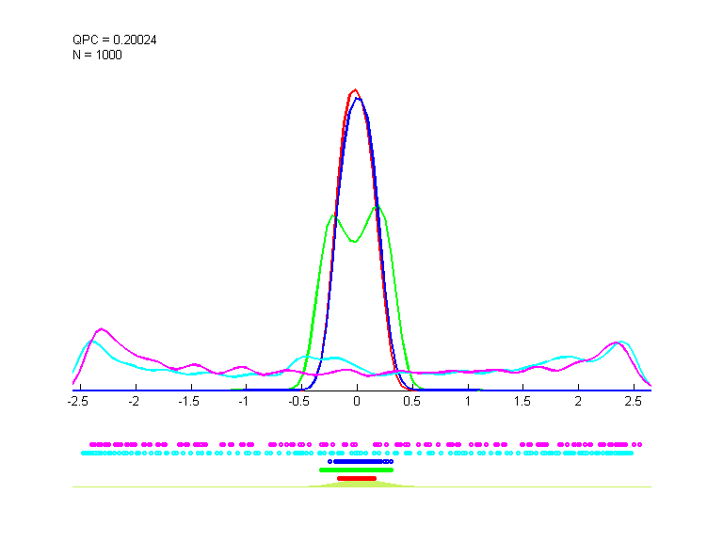
w1 = -0.2065 -0.1141 0.0294 -0.0135 -0.1322 -0.1839 -0.1134 -0.1404 -0.0888 -0.0374 0.0998 0.0196 -0.0695 -0.1452 -0.1104 -0.1505 0.0681 0.0914 0.1206 0.0550 0.0177 0.0355 -0.0057 -0.0638 0.1691 0.0843 0.0513 0.1358 0.1994 0.1538 0.0938 0.0343 0.0646 -0.1237 -0.2623 -0.0108 0.1620 0.1440 0.1170 0.0155 0.0312 -0.2494 -0.4201 -0.0325 0.1662 0.1281 -0.0341 -0.1395 0.0332 -0.0591 -0.0280 0.1003 0.1360 -0.0121 -0.1186 -0.1494 0.0530 0.0840 0.1486 0.1713 0.1263 0.0445 0.0102 -0.0898
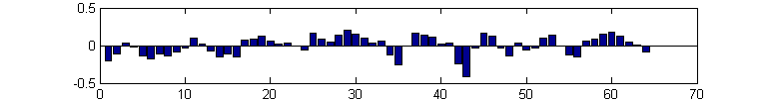
Drugi kierunek
lambda = 1.0
G(x)= σ(x+β)(1-σ(x-β))
β=0.3
learningRate = 0.1
maxIterations = 1000
initiations = 10
eps = 0.001
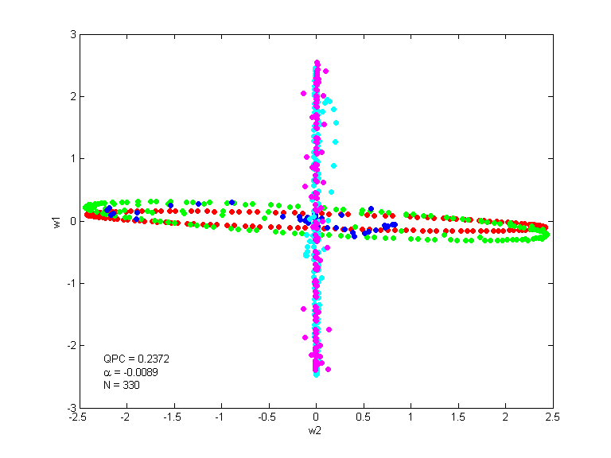
w2 = -0.0517 -0.0390 0.1067 0.0296 -0.0609 0.0597 0.0565 0.2663 -0.0317 -0.1342 -0.1190 0.1230 0.1804 0.1921 0.0027 0.1468 -0.1537 -0.1322 0.0042 0.0496 0.0754 0.0301 0.0186 -0.1560 -0.2050 0.0115 -0.0944 0.0811 0.1547 -0.1400 -0.1766 -0.1520 0.0862 -0.0710 -0.0644 0.0179 0.0690 -0.0498 -0.1600 -0.1820 -0.0977 0.0047 -0.1478 0.1721 0.2671 0.0625 -0.0545 -0.1220 -0.1903 -0.0483 0.0631 0.0305 0.2438 0.2124 0.1343 0.0566 -0.2088 -0.0473 -0.1848 0.1050 0.0800 0.1453 0.0837 0.0278
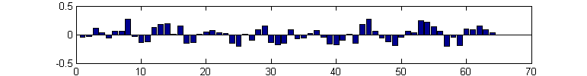

Rozwiazanie 3 (f. bicentralna, β=1.0)
Pierwszy kierunek
G(x)= σ(x+β)(1-σ(x-β))
β=1.0
learningRate = 0.1
maxIterations = 1000
initiations = 10
eps = 0.001
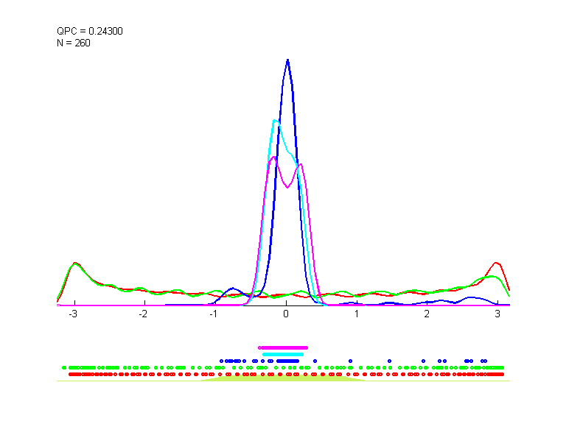
w1 = 0.1291 0.1220 0.0086 -0.1021 -0.0970 -0.1427 -0.1604 -0.1897 0.1891 0.0711 0.0046 -0.1354 -0.1256 -0.1135 -0.0876 -0.1267 0.2068 0.1540 -0.0175 -0.1067 -0.1476 -0.0712 0.0751 0.1208 0.1058 0.0889 -0.0479 -0.0900 -0.1726 0.0656 0.1790 0.1380 0.0632 0.0120 -0.0632 -0.1420 -0.1731 0.0542 0.1290 0.2120 0.0618 0.0481 -0.1201 -0.1373 -0.1533 -0.1330 0.0619 0.1256 0.1131 0.0540 -0.0257 -0.1528 -0.2187 -0.2207 -0.1124 -0.0366 0.1004 0.0997 0.0610 -0.0602 -0.1155 -0.2280 -0.1655 -0.1474
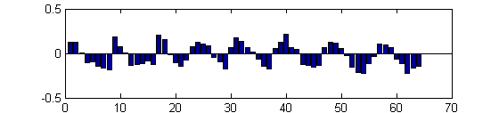
Drugi kierunek
G(x)= σ(x+β)(1-σ(x-β))
β=1.0
learningRate = 0.1
maxIterations = 1000
initiations = 10
eps = 0.001
lambda = 1.0
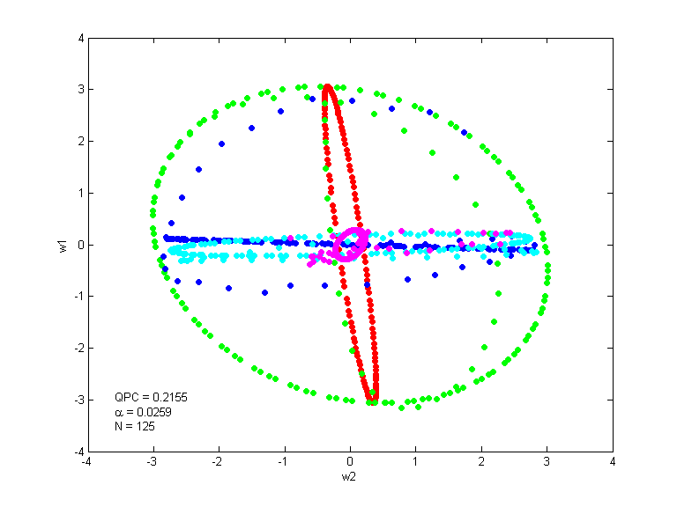
w2 = 0.2046 0.0000 -0.2006 0.0001 0.0570 0.2172 0.0621 -0.0660 0.2622 0.1497 0.0678 0.0639 0.0204 0.1824 0.1955 -0.0033 0.2581 0.0886 0.1955 0.1703 0.1997 0.1945 0.0392 -0.0028 0.0139 0.1203 0.2326 0.1580 0.1624 0.0565 -0.0497 0.0441 0.0894 0.0713 0.1600 0.0444 -0.0028 -0.1178 -0.1138 -0.0124 -0.0252 -0.0162 0.0716 -0.0419 -0.0829 -0.1604 -0.0975 -0.1384 -0.1770 -0.0472 -0.0589 -0.1439 -0.1273 -0.0940 -0.0746 -0.1042 -0.1170 -0.1628 -0.1065 -0.0918 -0.1637 -0.0445 -0.1122 -0.0417


